
Training Document for United States Coast Guard Enterprise Telehealth

October 27, 2020

Creating Accounts for Providers/Schedulers 4
1. Admin Tools > Click “Manage Providers” 4
2. Click “Add Provider” Button 4
3. Fill out these 5 fields: 5
4. Click “Orgs” Tab 5
5. Select Org and Role 6
Set Up A Schedule 7
1. Click “Manage Schedule” Calendar Icon at top of Dashboard 7
2. Search and select one or more providers under “Managing Schedule For.” 7
3. Under “Set Up Schedule” tab, click “Enable Schedule” toggle. 7
4. Select/enter the Following Fields 8
Manage Availability 9
1. Search/Select one or more providers under “Managing Schedule For.” 9
2. Click “Manage Availability” tab. 9
3. Select Filter under “Show Availability For.” 9
4. Click “Apply” 9
5. Open/Block By: 10
Manage Appointments 11
1. Search/Select one or more providers under “Managing Schedule For.” 11
2. Click “Manage Appointments” tab. 11
3. Select Filter under “Show My Appointments For.” 11
4. Click “Apply” 11
5. Appointment Options 11
Review Requests For a Video Visit 12
1. From the “Patient Care” List 12
2. Filter for “Assigned Provider Activities,” 12
3. Click on the “Activity” Icon 12
4. Follow the Instructions and Schedule the Video Visit 12
Schedule Video Visit 13
1. Click on the “TEAM” Tab 13
2. Click on the “Schedule Visit” Button 13
3. Optionally update the Date Filter 13
4. Select Available Time Slot 13
5. Enter the Visit Reason 13
6. Click the “Confirm Time Slot” Button 13
Join Video Visit 14
1. From SMS 14
2. From Email 14
3. From USCG Care Anywhere Website 15

Creating Accounts for Providers/Schedulers

About: We have already provisioned accounts for 220 providers/schedulers. However, only providers/schedulers at the pilot sites have been sent activation emails. Should you need to create additional accounts, follow the steps below. Provider/Scheduler usernames should be their full @uscg.mil email address (e.g. John.A.Smith@uscg.mil)

Admin Tools > Click “Manage Providers”

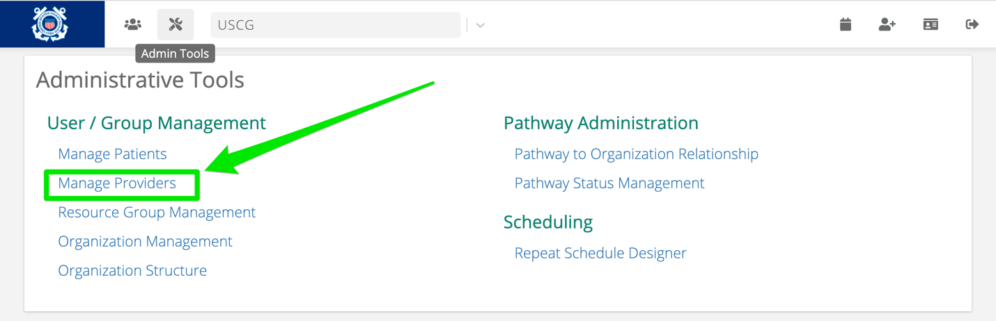

Click “Add Provider” Button

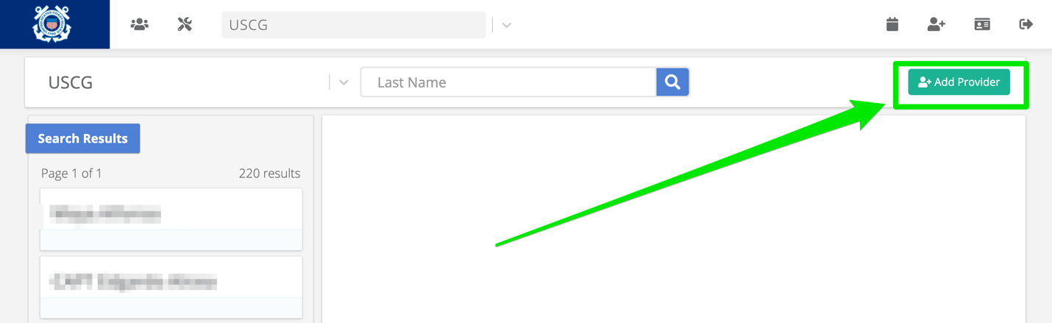

Fill out these 5 fields:

First Name

Last Name

Username

Email

Send Activation Email
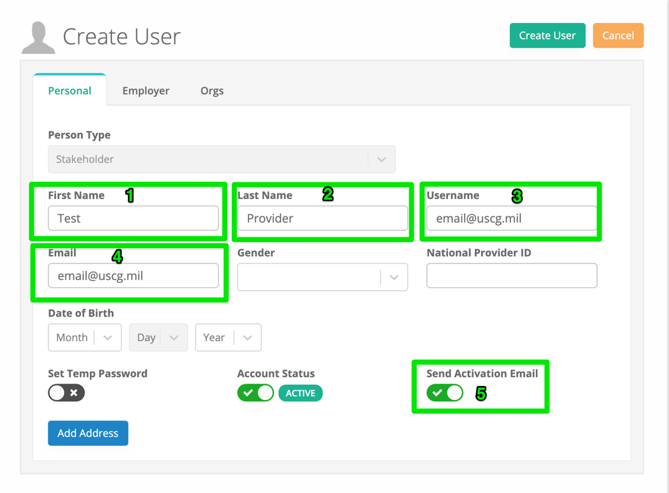

Click “Orgs” Tab
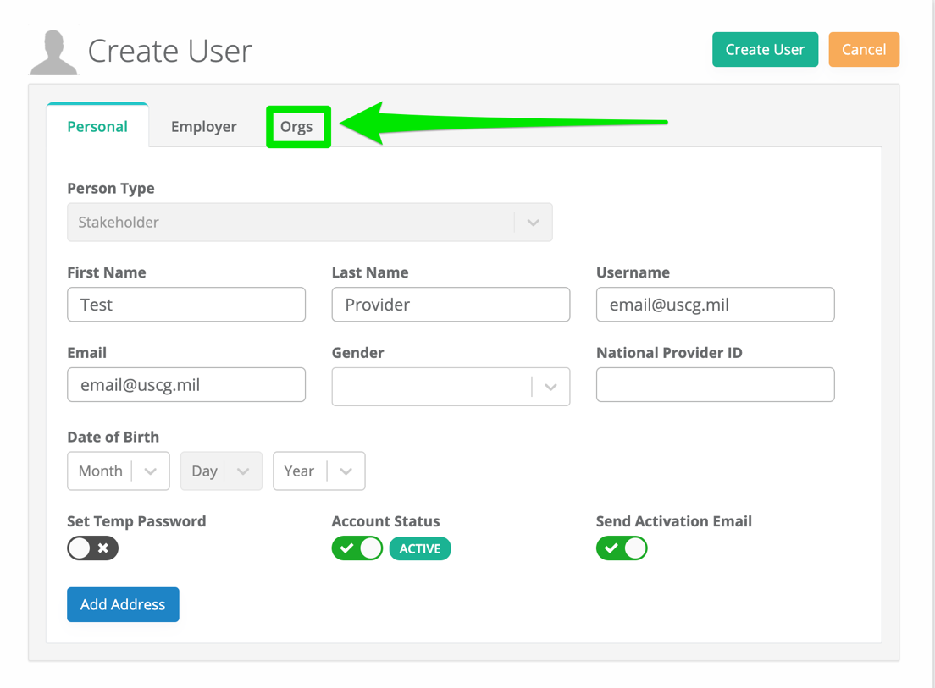

Select Org and Role

“USCG” Org

“Provider” as the role

Then click “Create User” button
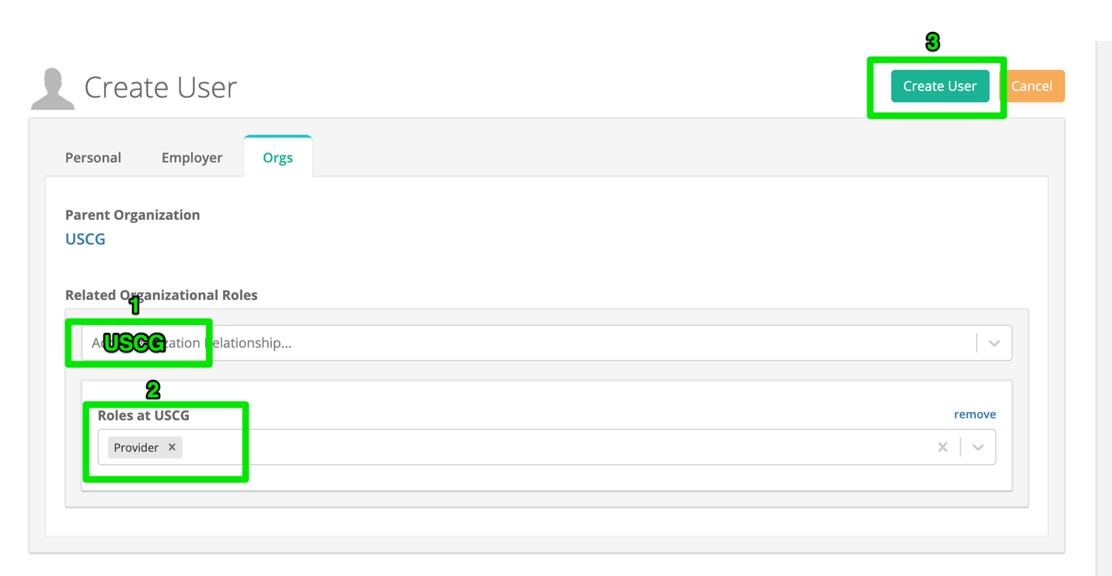

Set Up A Schedule

Click “Manage Schedule” Calendar Icon at top of Dashboard

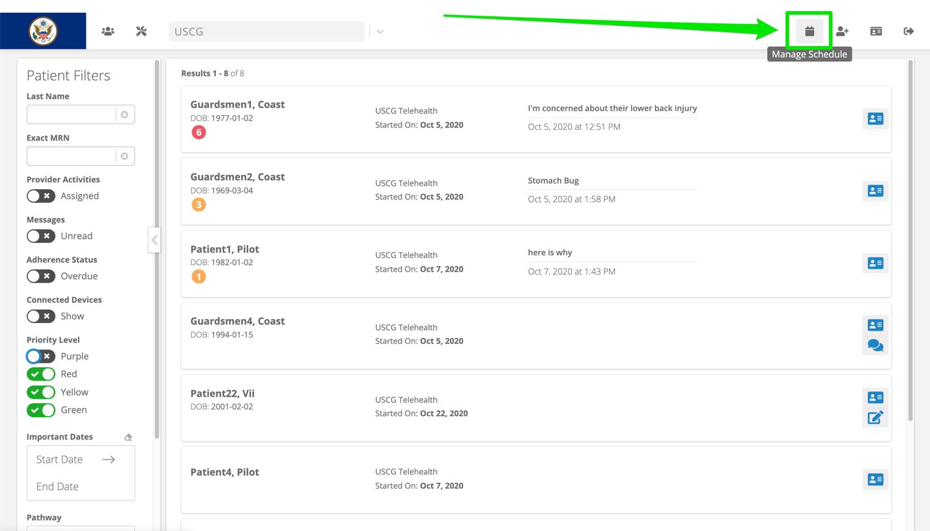
- Search and select one or more providers under “Managing Schedule For.”

- Under “Set Up Schedule” tab, click “Enable Schedule” toggle.

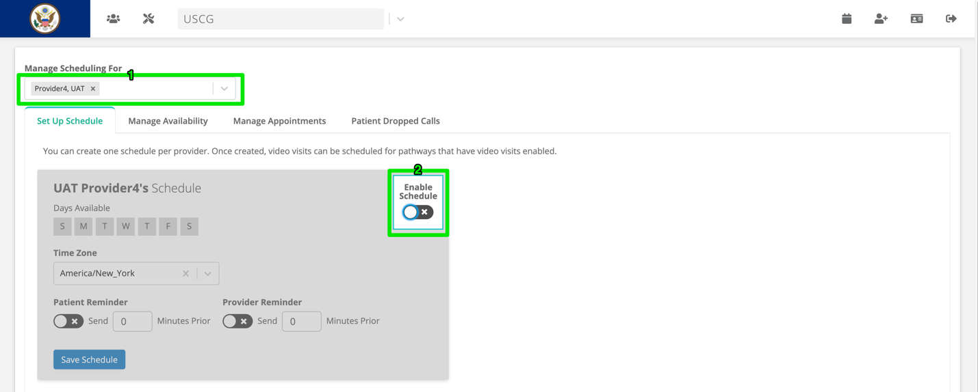

Select/enter the Following Fields

Days Available

Time Zone

Patient Reminder Toggle and Minutes Prior

Provider Reminder Toggle and Minutes Prior

Interval

Start Time

End Time

Generate Arrow

Save Schedule
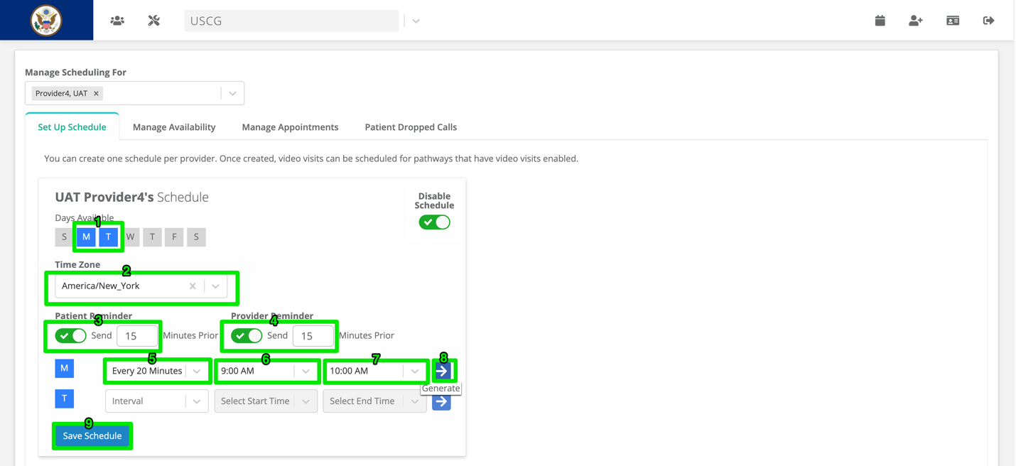

Manage Availability

Search/Select one or more providers under “Managing Schedule For.”

Click “Manage Availability” tab.

Select Filter under “Show Availability For.”

Click “Apply”

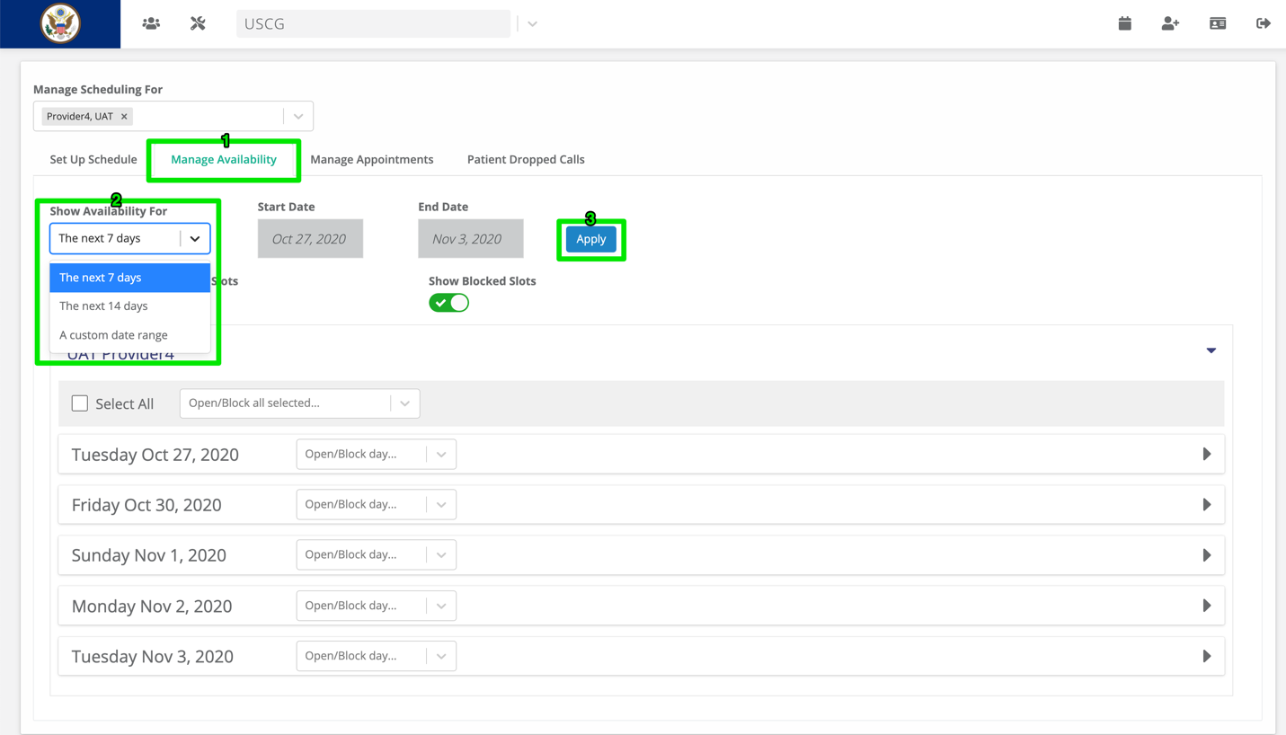

Open/Block By:

Timeslot

Day

Selected
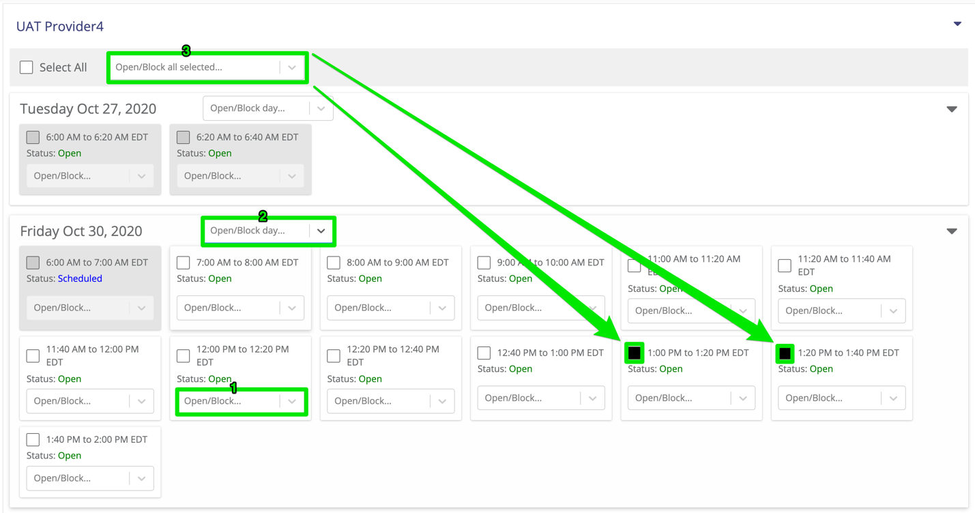

Manage Appointments

Search/Select one or more providers under “Managing Schedule For.”

Click “Manage Appointments” tab.

Select Filter under “Show My Appointments For.”

Click “Apply”

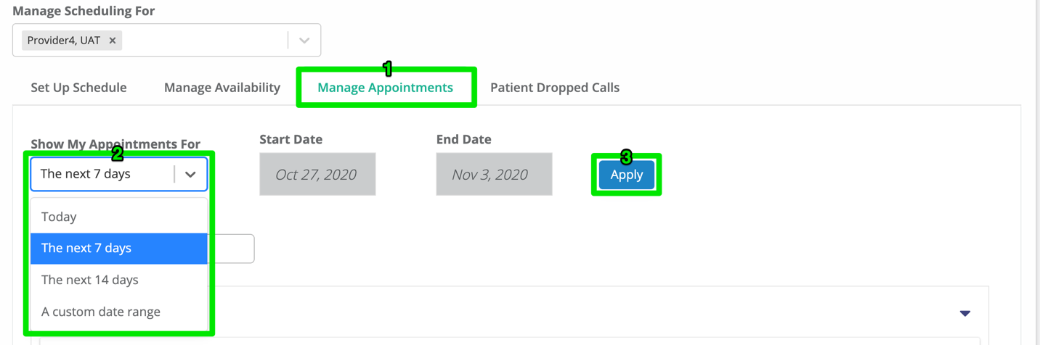

Appointment Options

Access Visit

Reschedule Visit

Cancel Visit
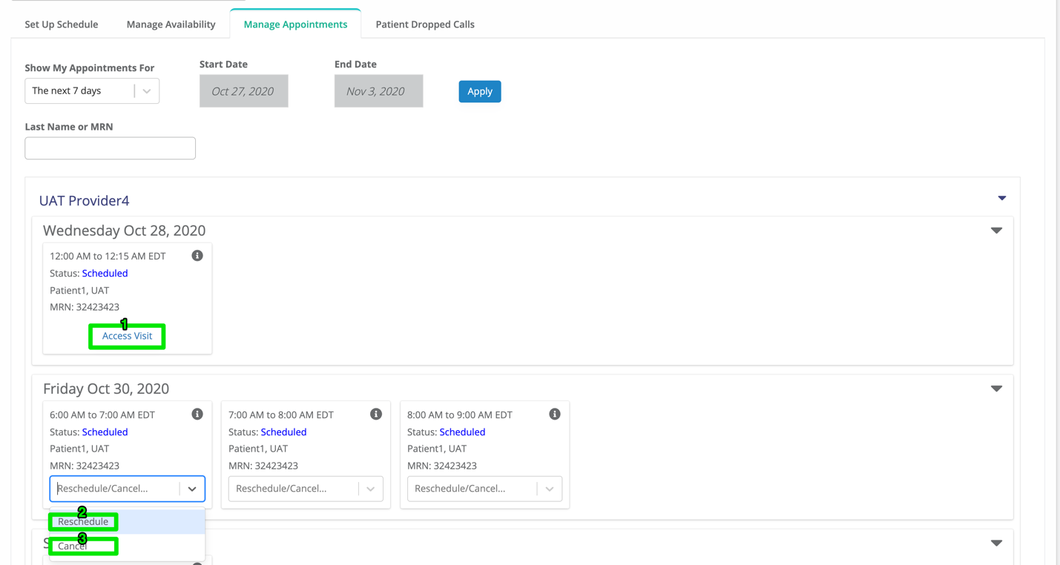

Review Requests For a Video Visit

From the “Patient Care” List

Filter for “Assigned Provider Activities,”

Click on the “Activity” Icon
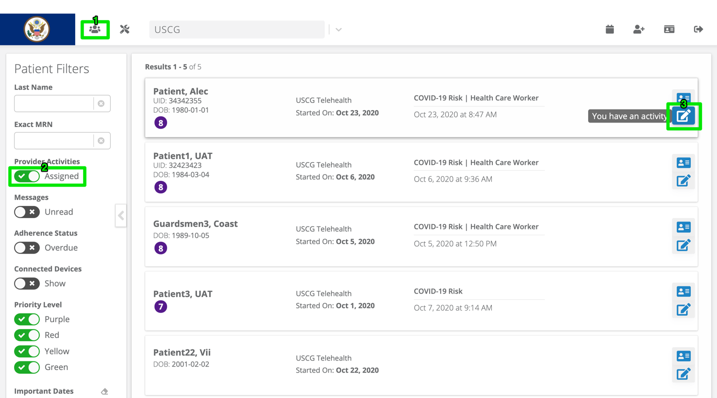

Follow the Instructions and Schedule the Video Visit
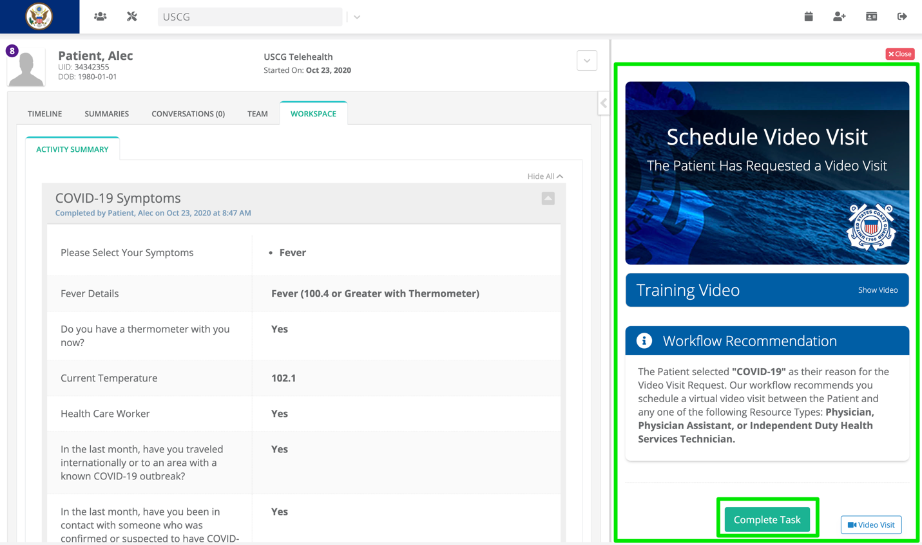

Schedule Video Visit

Click on the “TEAM” Tab

Click on the “Schedule Visit” Button

Optionally update the Date Filter

Select Available Time Slot

Enter the Visit Reason

Click the “Confirm Time Slot” Button

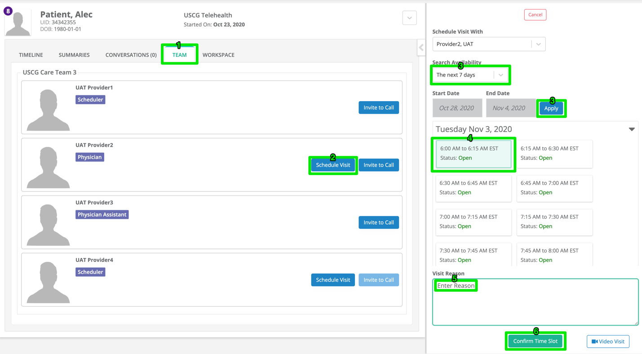

Join Video Visit

From SMS

Click link, log in, link will launch video visit
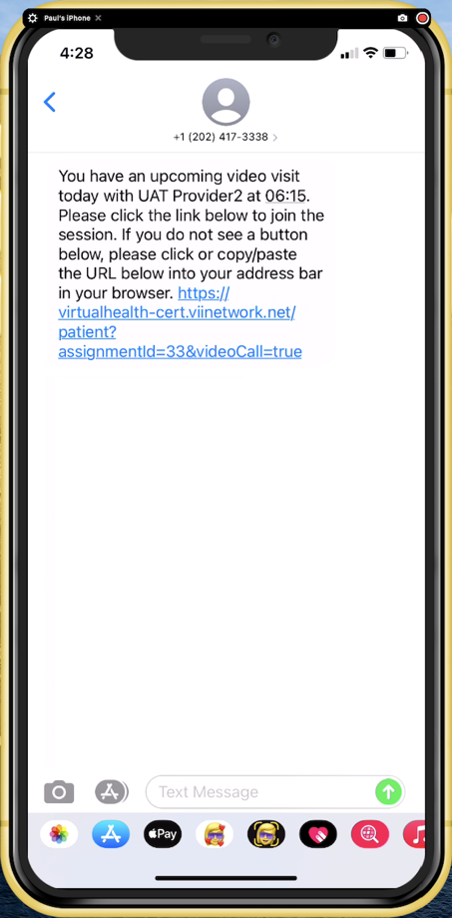

From Email

Click link, log in, link will launch video visit
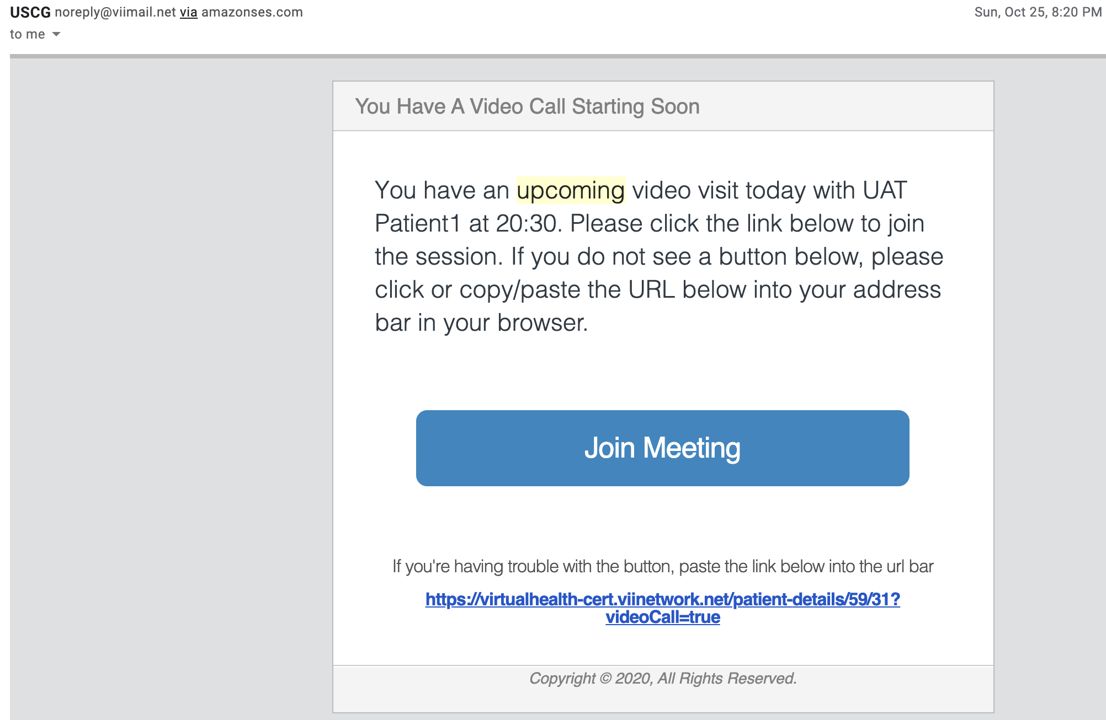

From USCG Care Anywhere Website

Click “Manage Schedule” Calendar Icon at top of Dashboard

Click “Manage Appointments” tab

Click “Access Visit” link on the appointment
